
April 2025
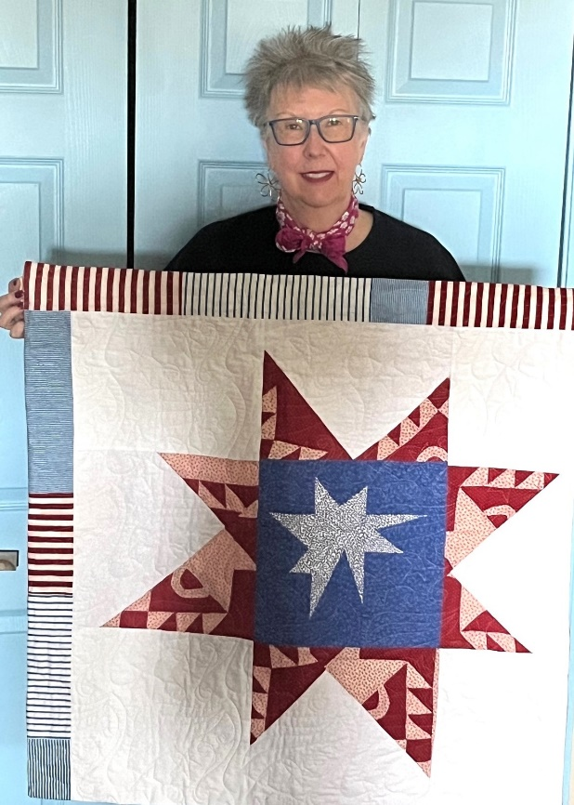 | Quincy Quilter to Help Celebrate Revolutionary War Events of 1775  Commemorating the 250th anniversary of the American Revolutionary War events of April 19, 1775, Concord Academy will host a free show, Quilts250: Stitching in the Spirit of Democracy. An art quilt by Quincy Sun columnist Barbara Graceffa has been accepted into the show chosen from among 350 entries.
Sponsored by the Concord250 Celebration Committee and three quilt guilds in the area, the event will showcase more than 200 quilts by talented artists from near and far. The two-day display will include five themes that reveal the dynamic range of quilting over the last 250 years. They include Spirit of 1775; Antique, antique-inspired, and traditional quilts; Quilts of protest; Modern, contemporary, and pictorial quilts; and Student quilts and fiber arts.
Graceffa explains, “My quilt really straddles two categories. The red fabric is left over from a torn, vintage basket quilt that I rescued from an antique store in Scituate and made into a smaller quilt. My wall hanging represents the antique and traditional quilt category while the wonky composition of the stars reflects the modern style of pictorial art quilts.”
The Quilts250 show takes place at the Concord Academy at 166 Main Street in Concord on Saturday and Sunday, March 22 and 23 from 10 AM to 4 PM each day.
A special exhibit, Quilts in Bloom, will feature quilts paired with floral arrangements by the Concord Garden Club. Visitors will also enjoy a display of comfort quilts made for local charities, a quality boutique, children’s activities, and an educational lecture Saturday at 5 pm on “American Quilts: The Art and Story of a Nation” ($10 for advance lecture tickets).
For more information, go to visitconcord.org.
Barbara Graceffa owns and operates Secretary of the Interior in Quincy, MA offering creative solutions at reasonable rates. Learn more about her decorating, downsizing, decluttering, home staging, home décor sewing services, and lectures at www.sec-interior.com. You can reach her at 617.921.6033.

