A member of the New England Quilt Museum’s Teachers League, Barbara Graceffa is an award-winning quilter and teacher, talented interior decorator, and published author who has taught quilters in the United States, Canada, Europe, and the Middle East. East. She has been honored with four solo exhibits. Her quilts hang in local and international juried quilt and art shows. They have appeared in local and national print publications and on local cable and PBS TV networks. Two quilts reside in museums in Boston and Ohme, Japan with others in private collections from Paris and Madrid to San Francisco and Sao Paolo, Brazil. (updated June 2025) | 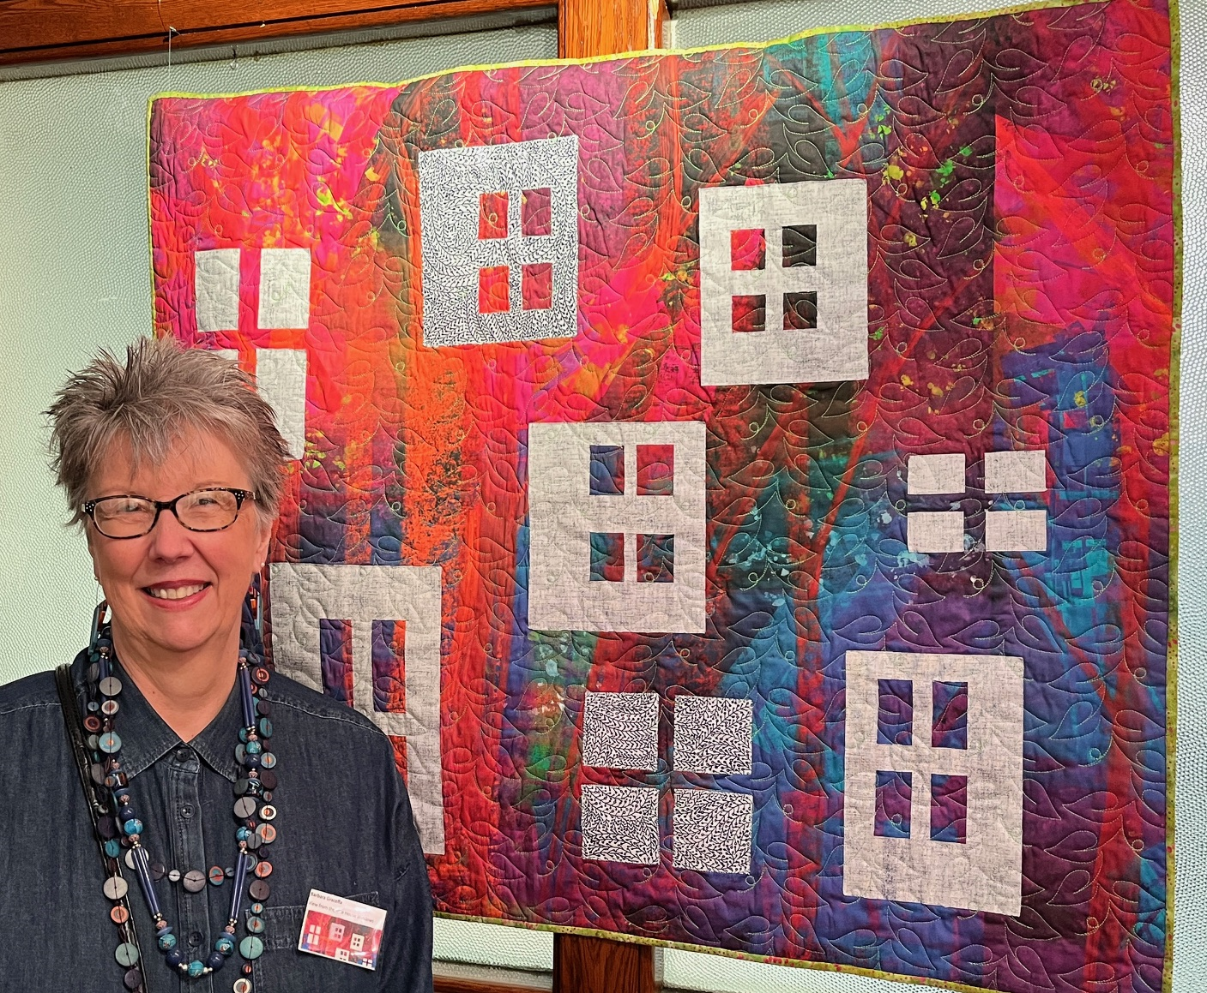
QUILT LECTURES AND SLIDESHOWS (available in-person and via Zoom)
- 7 Easy Steps to Achieve Color Harmony
- Gee’s Bend: The Artistry of “My Way” Quilts
- If Picasso Was a Quilter: How to Cultivate Your Creative Genius
- Keeping You in Stitches: Quilters’ Comedy Café
- Let It Go: Decluttering and Organizing Your Sewing Room
- Modern Quilts: Try It. You’ll Like It!
- Secret Codes in Quilts from the Underground Railroad﻿: Fact or Fiction?
- Setting Up Your Sewing Studio for Fun and Function
- Unintentionally on Purpose: An Introduction to Improvisational Quilts
LECTURES DESCRIPTIONS
7 Easy Steps to Achieve Color Harmony
Need some tried-and-true tips for putting fabric colors together for a quilt? Learn to choose colors that work well together and discover the emotions that each color evokes. ﻿Color theory will be demonstrated in show-and-tell quilts – Barbara’s and yours!
Gee’s Bend: The Artistry of “My Way” Quilts
Hear a short history of the descendants of enslaved cotton pickers from rural Alabama as they battled geographic isolation, economic hardships, and racial and political inequality. Then enjoy a slideshow of improvisational or “my way” quilts that the New York Times hails as “some of the most miraculous works of modern art America has produced.”
If Picasso Was a Quilter: How to Cultivate Your Creative Genius
Creativity is all about experimenting, taking risks, making mistakes, breaking rules, practicing, and having fun. Hear Picasso’s philosophy on art, jointly discuss which quilt styles he might have crafted, and see how Barbara's inner artist reflects Picasso’s lessons on creativity and manifests in an inspiring show-and-tell of her own creative quilts.
Keeping You in Stitches: Quilters’ Comedy Café
An amusing program of Barbara’s personal stories, insider jokes, silly poems, games, and trivia on fabric stashes, messy sewing rooms, UFOs, quilters’ husbands, and more – guaranteed to tickle your funny bone! Great fun for guild meetings or retreats.
Let it Go: Decluttering and Organizing your Sewing Room
Too much fabric? Too many books, rulers, gadgets you no longer use? Own a certain item, but just can’t find it? Well, this lecture is for you! An added bonus: Barbara’s three-step decluttering process applies to all spaces in your home.

Modern Quilts: Try it. You’ll Like it!
Have you been wanting to break free from traditional quilts to learn more about modern quilting? Wait no longer! You’ll discover the features of a modern quilt and see lots of examples of each. Barbara will finish the program showing her own modern beauties.
Secret Codes in Quilts from the Underground Railroad﻿: Fact or Fiction?
Learn the story of how the hidden meanings of quilt blocks informed enslaved African Americans on their journey to freedom. Barbara contributes her opinions on the validity of the oral history and shares great photographs of era-specific quilts.
Setting Up Your Sewing Studio for Fun and Function
Whether it’s a corner or an entire room, learn to create work zones and storage solutions (many of them budget friendly!) for all your sewing needs. You’ll also learn proper furniture heights and body mechanics for sewing, cutting, and pressing. Barbara will share lots of sewing and craft room pictures including those of her own “happy place.”
Unintentionally on Purpose: An Introduction to Improvisational Quilts
Try something new and fun! Barbara will define improv and controlled improv quilts, share their characteristics, and reveal her 9 Cs including choosing fabrics, styles, elements, and frameworks for a playful creative piece of art. Show and tell will follow.
LEARN MORE  View more of Barbara’s quilts on www.instagram.com/secretaryinteriordecorating/  Contact: barbara@sec-interior.com; 617-921-6033  Barbara Graceffa,  40 Greenleaf Street, PH 704  Quincy, MA 02169  PPictured: Out on a Limb  Barbara’s first quilt entered in an international juried show | 