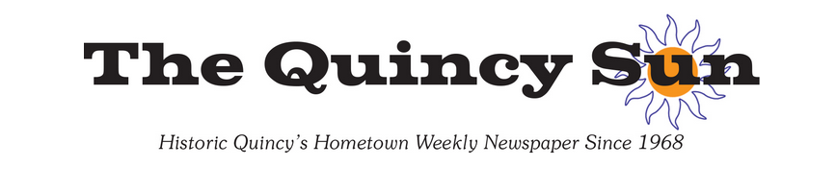
June 25, 2025
Quincy Quilter To Participate in Second MA 250 Event on June 28
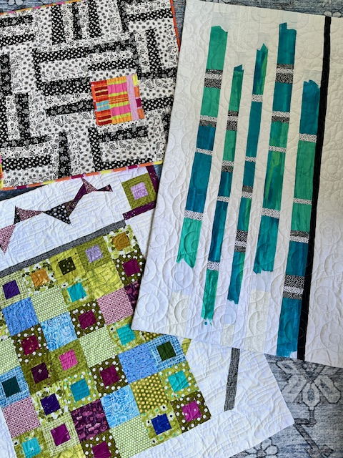
Quincy’s Barbara Graceffa will present a lecture and trunk show
on improvisational quilts at the Framingham History Center this weekend.

0n June 28 and 29, the Framingham History Center will present Stitching Revolution in Massachusetts: Quilting and Cotillions. Barbara Graceffa was invited to present a lecture and trunk show, “Unintentionally on Purpose: An Introduction to Improvisational Quilts.”
The event is a hands-on weekend blending quilting, history, and 18th-century dancing, all in celebration of Massachusetts’s pivotal role in the American Revolution. Open to everyone – from experienced quilters and history lovers to curious visitors – this two-day event at the historic Village Hall on the Common, invites the community to participate through creativity, storytelling, and movement.
On Saturday at 11 am, Graceffa will offer an introduction to improvisational (aka improv) quilts and show several of her own creations. A modern form of art quilting, improv quilts follow the “anything goes” philosophy to create beautiful one-of-a-kind designs. Unlike traditional quilting with patterns, rules, and restrictions, Graceffa uses colorful fabrics – both solids and prints - to create her unique wall-hangings.
“Improv quilts show great artistic expression where the free-form piecing grows organically. My quilts are typically minimalist and asymmetrical with negative space to rest your eye,” says Graceffa. “They are lots of fun and among my most favorite to make.”
She will also participate in a community quilting event in which quilters and quilt lovers from around New England can take part in creating quilt squares inspired by Revolutionary War themes. These quilt blocks will be sewn into a community quilt that tells a story through fabric. Materials and guidance will be provided.
For more information on other lectures including women’s sewing circles, family history in embroidery, and Framingham’s role in the American Revolution as well as the Saturday cotillion, visit framinghamhistory.org where you can also purchase tickets.

